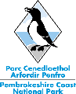

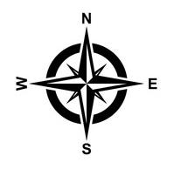
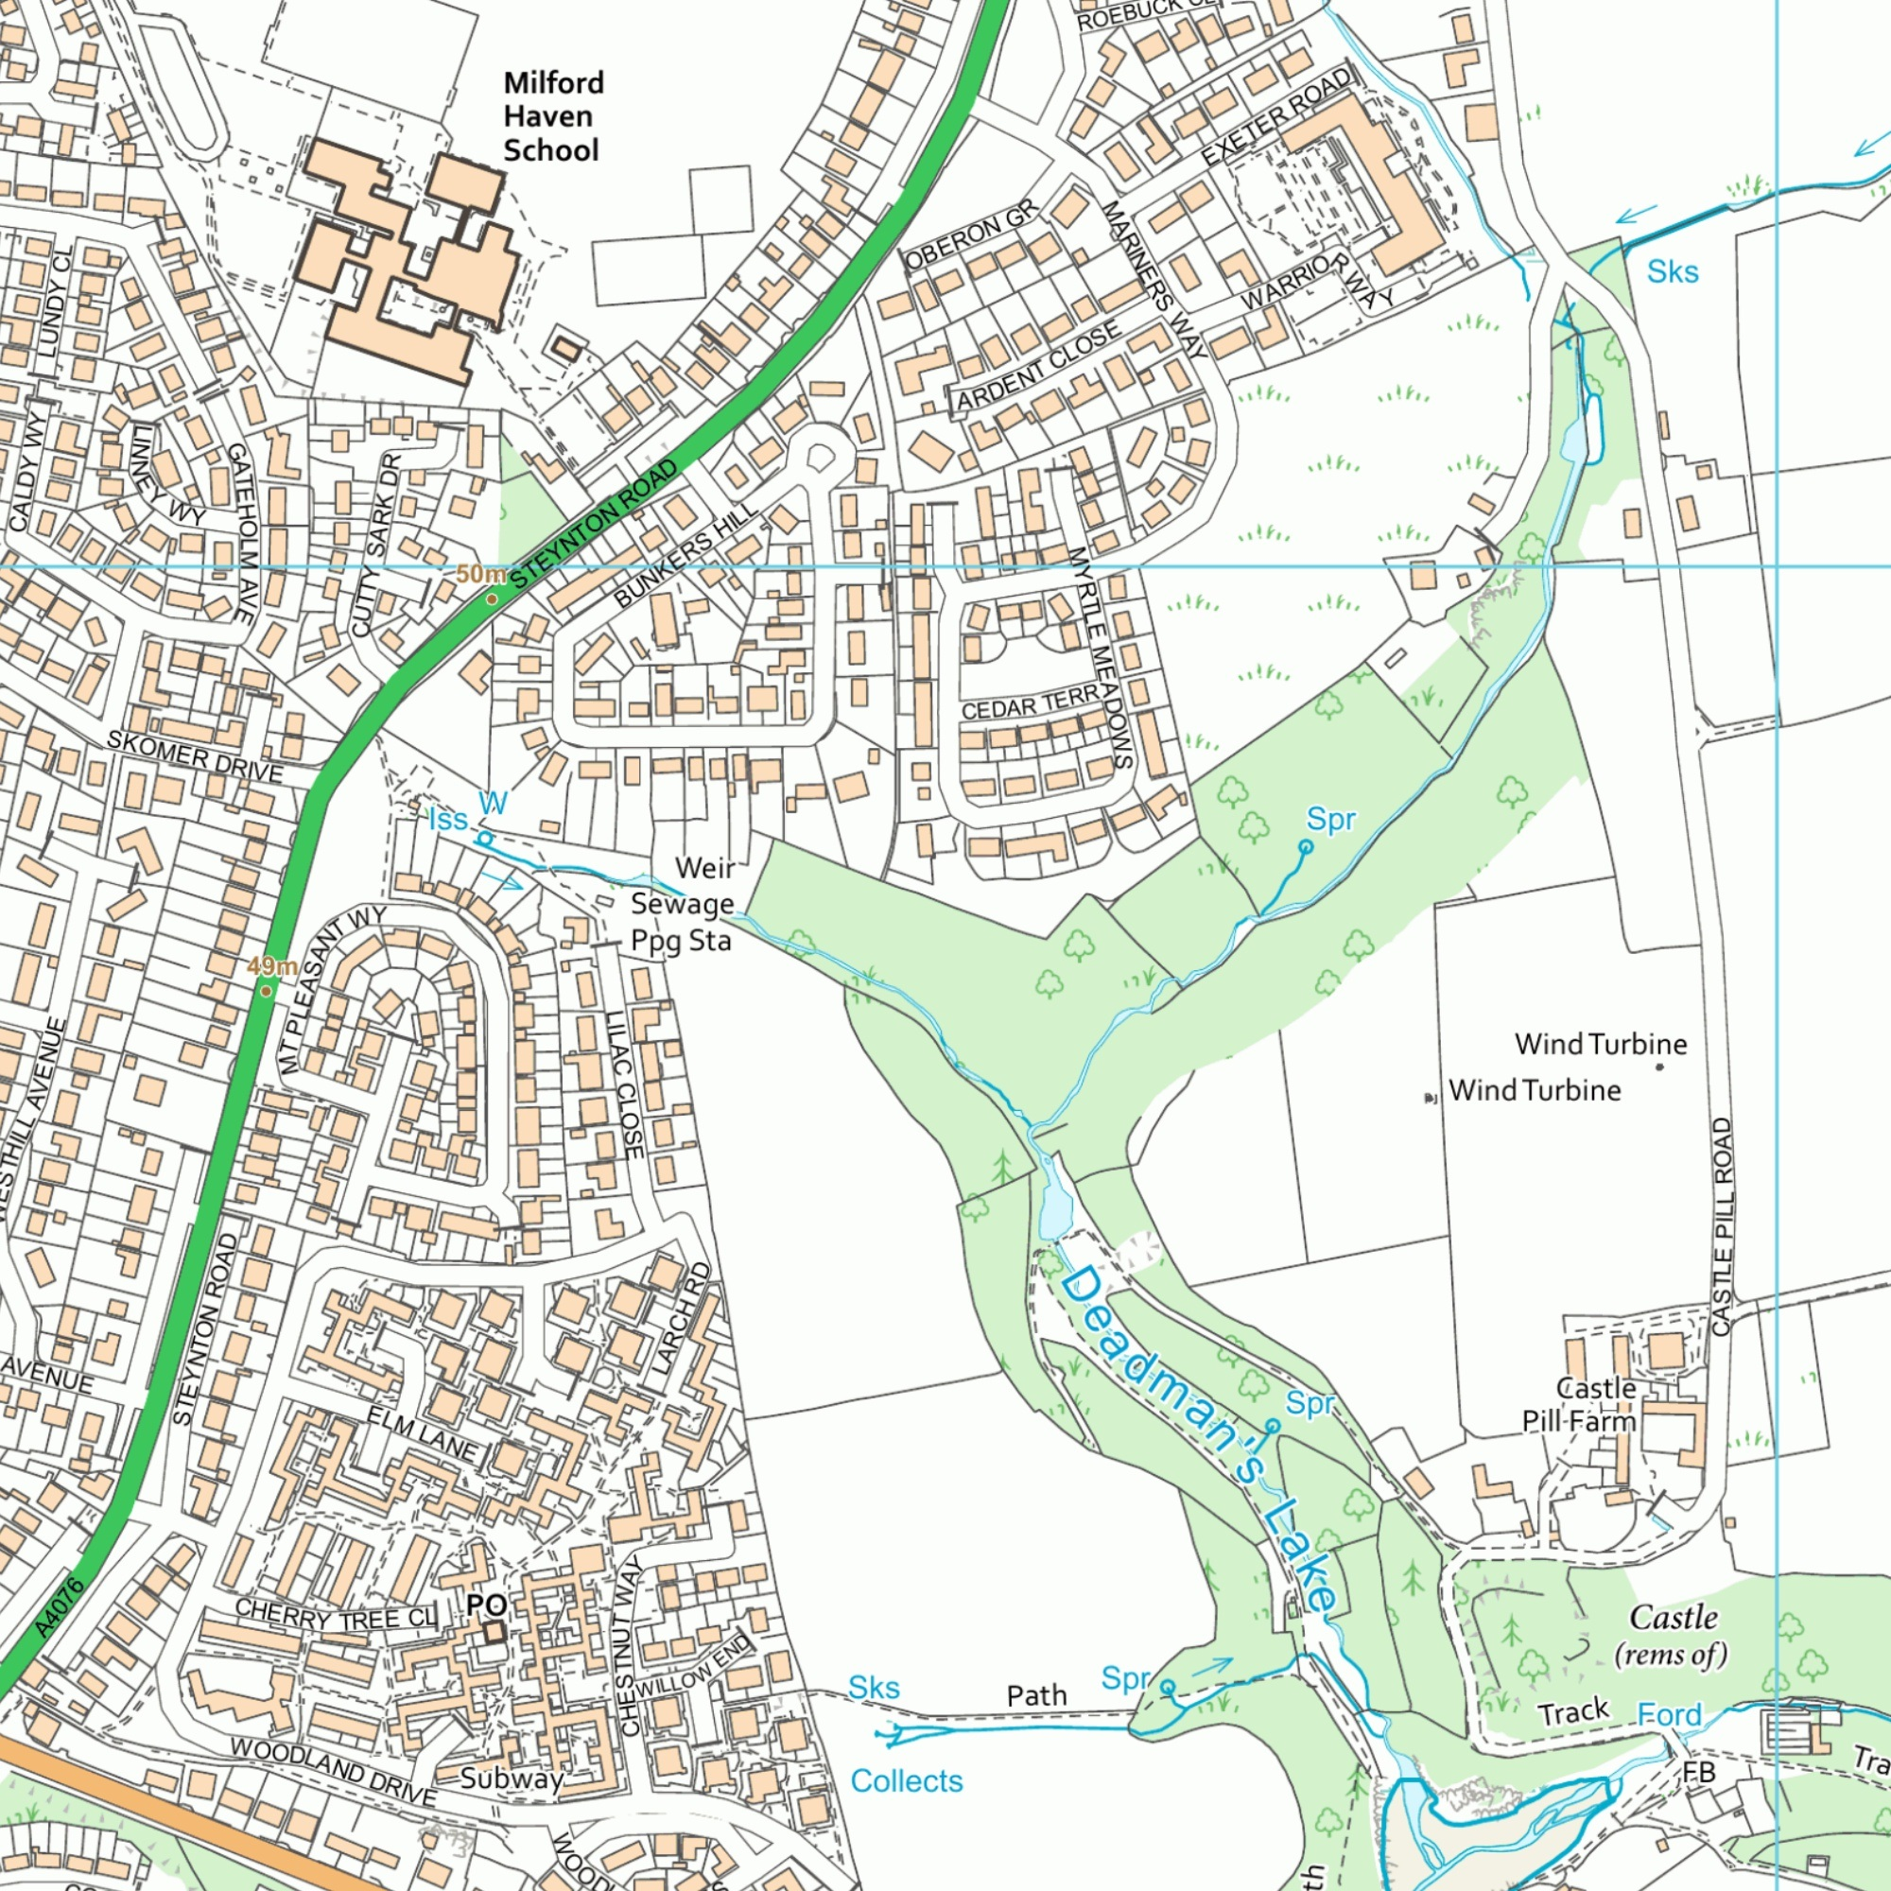
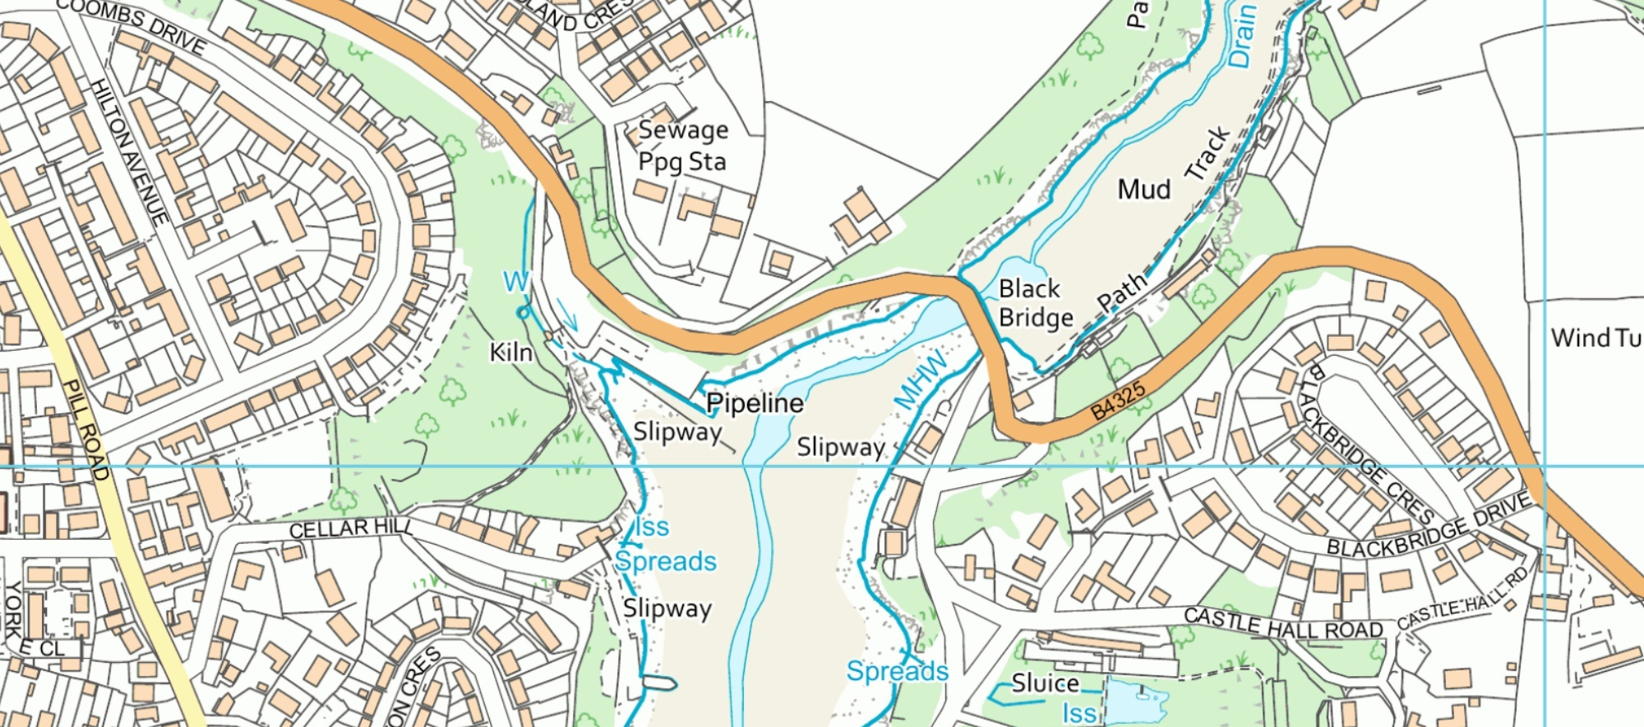
Species ID: Points:
1. _________________ ___
2. _________________ ___
3. _________________ ___
4. _________________ ___
5. _________________ ___
Total Points: ___ Average:___

Milford Haven School – Locality
Ysgol Gyfun Aberdaugleddau - Cynefin

Key
__________________
______________________________________________________
__________________

Tree ID:
1. ______________________
2. ______________________
3. ______________________
4. ______________________
5. ______________________

